Python statistics – Bin length with SE
Goal: Plot the cell length of a root binned on 0.025 mm intervals with mean and SE (SD/sqrt(n), n=1)
Log:
- Define a dataframe containing X, Q, id and L
- Add a new column to dataframe: binned position
> bin group by position successful
> Nominal length plot successful
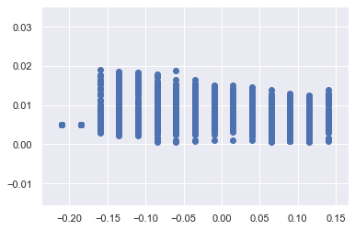
- Plot with means and error bars, automatic scaling
> Plots are good, but far stronger discrepancy with Beemster (that actually smooth their data)
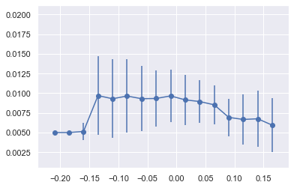
Closure: The data and figure are generated in a streamlined way. It requires the name of the simulation along with the set of .csv and return processed data and graphs of cell length statistics. Future work should endeavour the smoothening of the data in a Beemster fashion to reduce the standard error, along with minor graphics improvments (flip left right – from quiescent zone position)

